**CS 161 Week 9 in class Exercises**

1. In Spyder, try the following:

import calendar

cal = calendar.TextCalendar()

cal.pryear(2012)

* 1. What happens when you run the script? Take a partial screenshot to show what happens.

**The script prints the months for 2012.**

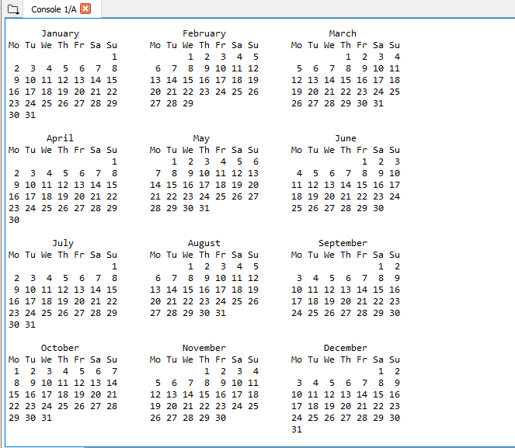

* 1. What day of the week does the above calendar start with?

**Monday**

* 1. Read the documentation for TextCalendar, and change the starting day to Thursday. Take a screenshot of the new calendar.

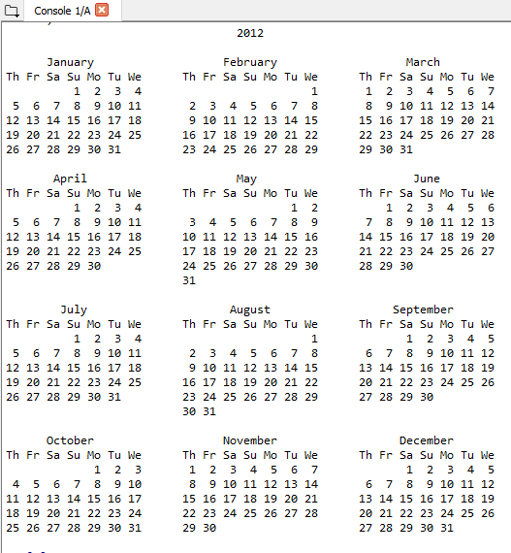

* 1. Find a function to print just the month in which your birthday occurs this year. Take a screenshot of your birthday month.

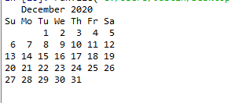

* 1. Try the following. Take a partial screenshot.

d = calendar.LocaleTextCalendar(6, "SPANISH")

d.pryear(2012)

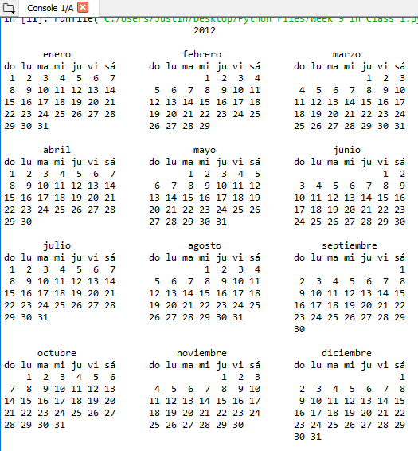

* 1. Try the same with a different language. Take a screenshot.

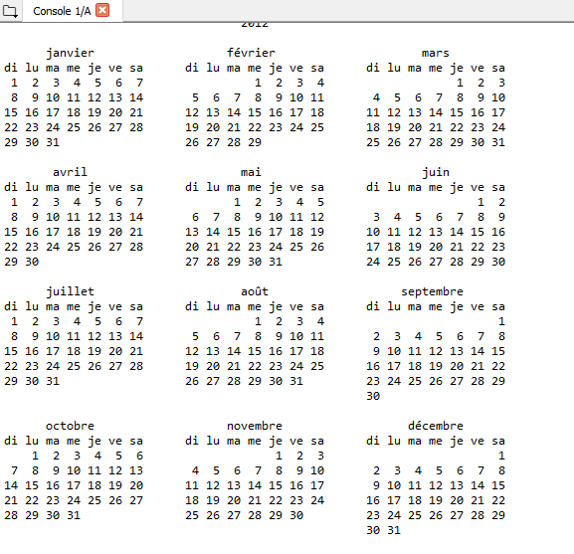

* 1. Experiment with ***calendar.isleap***.
     1. What does it expect as an argument?

**The year to be checked**

* + 1. What does it return as a result?

**True or False**

* + 1. What kind of a function is this?

**Boolean**

1. Name 5 functions from the math module, the arguments they expect, and what they do.

|  |  |  |
| --- | --- | --- |
| Function Name | Arguments | Job of the function |
| Ceil(x) | X | Rounds up x |
| Fabs(x) | x | Returns absolute value |
| Floor(x) | X | Rounds down x |
| Fsum(iterable) | [.1,.1,.1,.1] | Returns sum of the values in brackets avoiding loss of precision |
| Tanh(x) | x | Returns hyperbolic tangent of x |

1. In Spyder, use the 5 functions from Question 2 and show an example of how each works. Take a screenshot of each example.

With X=5.4:

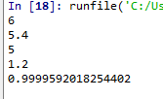

1. What are the two data constants in the ***math*** module?
   1. pi
   2. e
2. Investigate the ***copy*** module. What does ***deepcopy*** do?

**Deep copy is a process in which the copying process occurs recursively. This copies info into a secondary item, so if changes are made to one entity, both will not change.**

1. Use Spyder for the following:
   1. Create a module named **mymodule1.py**.
      1. Add an attribute ***myage*** set to your current age.
      2. Add ***year*** set to the current year.
   2. Create another module named **mymodule2.py**.
      1. Add attribute *myage* set to 0.
      2. Add **year** set to the year you were born.
   3. Now create a file named **namespace_test.py**.
      1. Import both of the modules above and write the following statement:

**print((mymodule2.myage - mymodule1.myage) == (mymodule2.year - mymodule1.year))**

* + 1. What is the output of the above print statement?

**False**

* + 1. Explain why some students get **True** while other students get **False**.

**If you have had your birth day this year, it will be True. For someone like me where their birthday is yet to happen this year, it’s false.**

* + 1. Why can we use the same attribute names (myage and year) in different modules and assign them different values?

**It has to do with the scope of the variables. They only exist inside of the modules, but they aren’t referencing the same spot.**

* 1. Take screenshots of your code and output.

  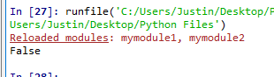

1. In Spyder interactive interpreter, try the following:

import this

* 1. What does Tim Peters have to say about namespaces?

**Namespaces are one honking great idea – let’s do more of those!**

1. What is the difference of the modules ***math*** and ***cmath***?

**Math doesn’t allow complex numbers but cmath does.**

* 1. List 5 functions from the cmath module.
     1. phase
     2. polar
     3. sqrt
     4. atan
     5. isfinitie
  2. The functions defined in ***cmath*** always return what type of number, even if the answer can be expressed as a real number? (integer, whole, complex, decimal)

**complex**